# 1.0 Abstract

In this assignment, HP's Victus 16 is chosen as the device for research. It is a strong and powerful gaming laptop that keeps up with the newest games at a more moderate price. This HP’s Victus 16 used an operating system called Windows 10. An operating system oversees all a computer's hardware and software. Without it, the computer would be useless. Besides, the people behind the creation of the hardware and software of this device are investigated for students to understand the expertise and skills needed for them in their future job. Combining evidence from reviews, personal correspondence, and diaries, this study aims to add insight and knowledge about the review and functionality of HP Victus 16 as the Computer Architecture and windows 10 as the Operating System.

# 2.0 Table of Content

1.0 Abstract 1

2.0 Table of Content 2

3.0 Introduction 3

3.1 Introduction to the device 3

3.2 Introduction to Company (HP) 3

3.3 People in HP 4

3.4 Facts and Stats about HP: 7

3.5 Introduction to Microsoft: 7

3.6 People in Microsoft: 8

3.7 Facts and Stats about Microsoft: 10

4.0 Hardware Specifications 11

4.1 Introduction to the device (showcase): 11

4.2 Tables of the most significant hardware components 14

4.3 Conclusion of hardware 17

5.0 Operating System 17

5.1 Functions and Capabilities in Windows 10 17

5.1.1 Start Menu 18

5.1.2 Microsoft Edge 18

5.1.3 Multiple Desktops and Task View 19

5.1.4 Tablet Mode 19

5.1.5 File Explorer 20

5.2 Security Services in Window 10 26

5.2.1 Windows Hello 26

5.2.2 Microsoft Defender 26

5.2.3 Automatic Updates 27

6.0 The Conclusion: 28

7.0 References 29

8.0 Appendices 32

8.1 Work Breakdown Structure 32

8.2 Minutes of Meeting 33

8.3 Frequently Asked Questions 35

8.4 Gantt Chart 37

# 3.0 Introduction

## 3.1 Introduction to the device

The HP Victus 16 is the first entry in HP’s new Victus line of gaming laptops, which feel intended to be more affordable druthers to HP’s auspice gaming laptops, the operating system is that used for this device is Windows 10 and the main provider for this operating system is Microsoft company (Tom’s Guide, 2022). It presents a satisfactory quantity of power for a fair cost and comes in four models with prices ranging between 250$ to 810$. It comes in Ceramic White, Mica Silver, and Performance color schemes. The HP Victus is constructed well. Even though it is made completely of plastic, it feels strong and is well-built. Even while the HP Victus 16 is quite slim for a gaming laptop, it is nonetheless bulky and hefty. Victus weighs 5.4 pounds (2.4 kilos). A camera that produces 720p, an output for HDMI for connecting to a screen, and a committed Ethernet connector for a strong connection are also included. These features make it possible to download enormous games and play online at dependable rates (Fillari, 2022). The Victus has three USB-A (5Gbps) connectors, one of which may be used for Sleep and Charge, and one 5Gbps USB-C port. This enables it to connect to two 4K screens, one through a USB-C connector and the other using an HDMI cable. That effectively makes a Thunderbolt port unnecessary (Hachman, 2021). The Victus comes with a basic 16.1-inch FHD (1920 x 1080 pixels) display with a refresh rate of 144Hz. However, you may select one with a little brighter screen to get a model with a greater resolution (2560 x 1440 pixels) (additional price) and a refresh rate of 165 Hz. the Victus is equipped to give the finest gaming performance at 1080p (Tom’s Guide, 2022). The Victus offers a captivating full-HD display with sharp images, and the 144Hz refresh rate creates a fluid appearance and feels for on-screen activity. It supports 100% of the sRGB color gamut, and colors are vivid. And of course, how hard you use the hardware will affect how long the battery lasts, so normally, the HP Victus' battery life is little more than 5 hours, which is sufficient for brief periods when moving (Fillari, 2022).

## 3.2 Introduction to Company (HP)

Hewlett-Packard (HP) is a well-known technology company providing technology solutions to consumers, businesses and all kinds of institutions worldwide. It is the company that developed the laptop, HP Victus 16. Besides making laptops, HP also grows its business into providing IT infrastructure, access devices and printing services as well as global services. HP has a global reputation thanks to its operations in more than 170 nations. The founders of HP are Bill Hewlett and David Packard who were classmates studying electrical engineering at Stanford Universities. HP had been established in Palo Alto, California on 1 January 1939. Hewlett-Packard grew its global activities in the 2000s by constructing research centres in India (2002), China (2005) and Russia (2007). These facilities joined those in England (1984), Japan (1990) and Israel (1994) (Mark Hall, 2022). HP divided into two companies in November 2015 which are HP Inc and Hewlett Packard Enterprise. HP Inc produces IT hardware and software to develop more advanced PCs, laptops and printers while Hewlett Packard Enterprise is more focused on providing services for businesses in the field of storage, servers, networking and support.

## 3.3 People in HP

There are the important people in HP:

|  |  |  |
| --- | --- | --- |
| Figure 1: Enrique Lores | Figure 2: William Redington Hewlett | Figure 3: David Packard |

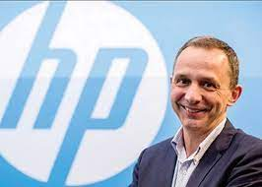

Enrique Lores began working with HP thirty years ago as an engineering intern. He is 54 years old and a native of Madrid and a graduate of the Polytechnic University of Valencia in electrical engineering. Lores finally attained the position of the head of HP's printing division and also holds an MBA from Barcelona's ESADE Business School (Feldman, 2019). HP Inc.'s current president and CEO is Enrique Lores skilled commander with a broad range of skills, Lores. Since becoming CEO at the end of 2019, he has been directing an audacious plan to improve HP's management in personal printing and computing, reform business procedures to better serve its customers, and disrupt industrial markets with HP innovations that are transforming the industry. He had a significant impact on HP's cost structure, business streamlining, and ability to engage in innovation that would lead to profitable top-and-bottom-line growth. He has been the impetus behind HP's dedication to environmental sustainability and has spearheaded projects to have a beneficial impact on individuals, the environment, and populations worldwide. Lores is a staunch defender of HP's basic values and its Sustainable Impact strategy, which aims to strike a balance between societal and commercial needs (Lores, n.d.).

William Redington Hewlett, who founded HP, was a well-known business figure in the United States of America. He was born in Ann Arbor, Michigan, on May 20, 1913, in the United States. When he was granted the chance to teach at the Medical School of the University of Stanford, his father, a professor at the University of Michigan, moved to San Francisco with his family. He was accepted to Lowell High School for his early education, and for his post-secondary studies, he enrolled at Stanford University. In 1934, he graduated with a bachelor's degree from the same college. He continued his education at MIT, where in 1936 he earned a master's degree in electrical engineering. In 1936, he reapplied for the same electrical engineering degree at Stanford University. Electrical engineering was his passion, as evidenced by his number Stanford University electrical engineering degrees. His passion in the field led him to start Hewlett Packard, one of the titans of the industry. In Palo Alto, California, on January 12, 2001, William Redington Hewlett passed away. He was about 87 years old when he passed away. He is still regarded as the creator of the fundamentals of the modern computer era (Jin, 2014).

The second founder of HP, David Packard, was a well-known American electrical engineer. On September 7, 1912, he was born in Pueblo, Colorado, in the United States. Due to his passion for science and sports, he was accepted to Centennial High School for his basic schooling. Early on, he was known as a top student. He continued his education at Stanford University, where he earned his B.A. in 1934. David Packard chose to seek a master degree in this field after his interest in electronics and computers unexpectedly increased. Then, he applied to Stanford University and enrolled in order to get his master's in electrical engineering. After getting his degree, he started working for General Electric, but he kept taking electrical engineering classes provided by several organizations. David Packard passed away in the American city of Stanford, California, on March 26, 1996. He was 83 years old when he passed away. In the current computer industry, his co-founded company, HP, is a titan known for its distinctly styled laptops and other products. (Jin, 2014).

## 3.4 Facts and Stats about HP:

At the end of 2021, HP's net earnings were $6.5 billion in terms of market sales and the earning revenues of HP were $63.5 billion. For this amazing sales data, HP spent $829 million on advertising globally in 2021. According to employee statistics, HP Inc has around 51,000 employees working for it globally in 2021. According to HP product statistics, the declining cost of raw materials used in computer manufacture allows HP to make the majority of its profit from desktop and notebook computers. In 2021, 65.5 million PCs is shipped. The selling of HP printers is the company’s second-largest source of income. With a historical market share of between 15 and 25 percent, HP Inc. continues to be one of the key participants in the worldwide PC industry into 2022 (Thomas Alsop, 2022).

## 3.5 Introduction to Microsoft:

Microsoft is the world's largest manufacturer of computer software. It also ranks well as a provider of cloud computing, video games, computer and gaming equipment, and other online services like search. Microsoft has operations in over sixty different nations, with its main office in Redmond, Washington, etc. In 1975, Bill Gates and Paul Allen, who were 2 colleagues at Harvard University, they created Microsoft to provide a compiler for the Altair 8800. Gates asked to create software for the new computer and contacted the manufacturer, (MITS) Micro Instrumentation and Telemetry Systems. Gates and Allen created an interpreter for BASIC, a mainframe programming language at the time, for use with Altair 8800. At the same year, MITS employed Allen and Gates, but by 1976, they had left to concentrate more of their efforts on their startup business, Microsoft, which it had established in 1981. At the same year, IBM employed the business to build an operating system for its work device. IBM offered a version of the operating system known as PC-DOS under the name MS-DOS (Microsoft Disk Operating System). IBM and Microsoft had seen a tremendous success in the early 1980s. When Windows was released in 1985, it was originally known as Interface Manager, a graphical user interface that operated on top DOS (Patrizio & Bigelow, 2017). (OS) computer's operating system, sometimes recognized as Windows, is a set of software programs. It was created by Microsoft in November 1985, and updates have been made periodically ever since as technology has advanced (larger computer memory, faster processor chips, and, of course, the creation of the internet). Before Windows, text commands were used to control PCs (Digital unite, 2021).

## 3.6 People in Microsoft:

There are several important people we need to know behind the creation of Windows 10 by Microsoft.:

|  |  |  |
| --- | --- | --- |
| Figure 7: Satya Nadella | Figure 8: Terry Myerson | Figure 9: Gabe Aul |

Satya Nadella become the Chief Executive Officer (CEO) of Microsoft in 2014. He is now 55 years old. After he graduated from Mangalore University with degree in electrical engineering, he earned his master's in computer science from the University of Wisconsin Milwaukee. Besides, he also has a master’s degree in business administration from the University of Chicago. He joined Microsoft in 1992 as an employee and he gained a reputation as a leader who could work across a variety of industries and technology to revamp some of Microsoft's most important product lines. For example, he assisted Microsoft in bringing its development tools, Windows Server and database to its Azure cloud. His expertise in cloud computing technology helps him to succeed in leading the transition to the cloud infrastructure and services sector, which outperformed its rivals and gained market share. He also writes a book named Hit Refresh to talk about his career at Microsoft and the way technology influences the future. He declared that Microsoft Philanthropies will donate the book's profits to non-profit groups. The leadership of Satya Nadella leads Microsoft to success in the market of technology.

Terry Myerson is a 50-year-old Microsoft employee who designed Windows 10. He graduated from Duke University with major in mechanical engineering and founded Interse Corporation which Microsoft acquired in 1997. He is a trustee for the Seattle Foundation and a board visitor for the Pratt School of Engineering at Duke University. At Microsoft, Terry Myerson worked as the head of mobile engineering before he became executive vice president of operating systems in July 2013. From the start of the Windows 10 building process, the Windows Insider program had started, customers are virtually involved and saw the preview program of Windows 10. The feedback from these customers was taken to improve Windows 10 and also avoid the mistakes made in Windows 8. This risky idea was given by Terry Myerson, even though he was worried that letting clients see Windows first may turn some of them away for good. However, he never regrets the decision because this made Windows 10 development collaborative (Goldman, 2015).

Besides Terry Myerson, Gabe Aul who is the engineering general manager for Microsoft’s operating systems group in 2013 contributed a lot to creating Windows 10. He was born in Colorado and likes to drive and work on cars, tinker with software, electronics and 3D printing. He is now 50 years old. After he graduated from the University of Washington, he started working at Microsoft. His excellent skill in software project management let him become the engineering general manager for the first release of Windows 10 in 2013. He led a 400-person organization that included Software Engineers, Program Managers, and Data Scientists. In leading the team, he completely transformed how they do software delivery and release in Windows. He and his team went from releasing products every 3 years with one or two beta releases, to shipping major updates every 6 months and flighting builds weekly to the largest group of beta testers in the world. He led the team to fix the problems and bugs according to the feedback from the technical enthusiasts who joined Windows Insider Program. Before Gabe Aul was responsible for Windows 10 testing, he worked in the product support department for 23 years. This made him a passionate person to quality. The craftsmanship of Terry Myerson, Gabe Aul, and their teams created Windows 10 successfully.

## 3.7 Facts and Stats about Microsoft:

Microsoft’s global revenue in 2021 is reaching a record high of over $168 billion and the net income of the company is $61.3 billion. The commercial licensing of Microsoft's software and other operating systems have been the main source of the company's income. The market for cloud computing is becoming increasingly important to Microsoft's overall company. Microsoft is well-positioned in this industry-wide transition to the cloud since it is one of the leading cloud service providers. Besides, Microsoft dominated the PC operating system and recently success with the selling of Xbox One gaming consoles which over millions of units. According to research, Microsoft’s Windows has a leading 75% global market share among desktop operating systems in October 2022 (*Microsoft Statistics - Microsoft Facts, Stats, Trends & Data (2022) | WallStreetZen*, 2022).

# 4.0 Hardware Specifications

## 4.1 Introduction to the device (showcase):

The hp victus 16 is a new family from the hp gaming laptop lineup. In terms of price, this is more affordable than the price of other HP laptops. The name Victus on this laptop is because the V symbol on the laptop symbolizes valor, which means courage. The V symbol looks very dashing. Victus 16 cellphone is divided into 3 colors, namely mica silver, performance blue, and ceramic white. This ceramic white color uses materials that are recycled using around 341 thousand plastic bottles are recycled, therefore this HP product gets an energy star certificate because the product is environmentally friendly. In the corner of the hinge of the Victus pro laptop, he uses his trademark Omen, and the hinge is simple and there is also a simple small Victus inscription (DKID, 2021).

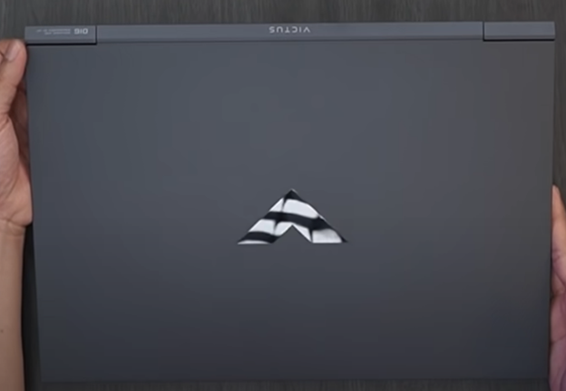

Figure 10: Hp Victus 16 logo

This HP Victus laptop can be opened with one hand with a slightly wobbled hinge so it can't be locked and opened up to 180 degrees. For the audio it uses bang and Olufsen, then the keyboard interface shows the characteristics of HP Omen, like the font, Numpad, and arrow keys, which are also suitable for use for games. The trackpad is also more suitable so that when you want to use a laptop without a mouse, it can also be comfortable. The keyboard is also equipped with a single white LED backlight. on the screen, the frame is thinner. The dimensions of this laptop screen are 16.1 inches. With specifications 16.1" diagonal, QHD, 165 Hz, 3 ms response time, IPS, micro-edge, anti-glare, Low Blue Light, 300 nits, 100% sRGB4. (Terafied, 2022)

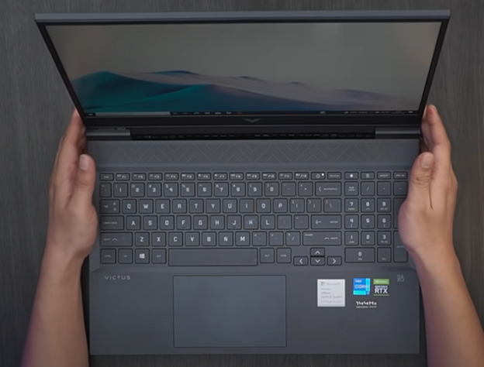

Figure 11: Hp Victus 16 interface

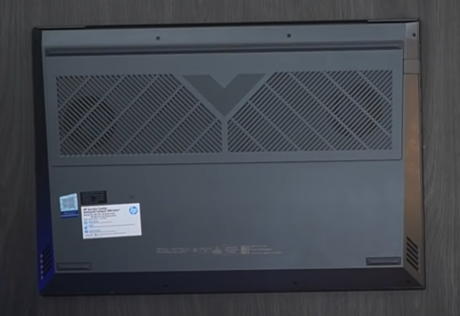

Figure 12: Hp Victus 16 backside

For the port on the left side, there is an SD card slot, audio jack, type c, type a, HDMI input, and audio jack.

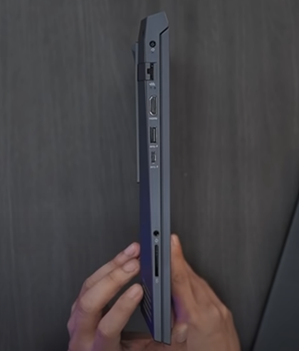

Figure 13: Hp Victus 16 left side port

On the right side, there are 2 USB types a. (Jarrod'sTech, 2021)

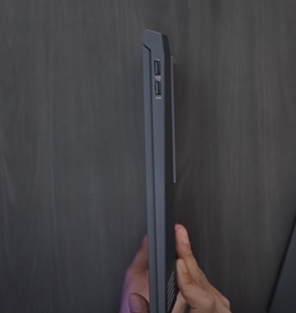

Figure 14: Hp Victus 16 right side port

## 4.2 Tables of the most significant hardware components

|  |  |  |
| --- | --- | --- |
| **Component** | **Specification** | **Rating** |
| CPU | **AMD Ryzen 5800H** | 4/5 |
| **Description** | | |
| 5800H is a laptop processor which has 8 cores, 16 threads, L2 cache – 4 MB, L3 – 16 MB that runs on 3.2 Ghz in stock and with max boost up to 4.4Ghz. Energy consumption 35-54W, max operating temperature - 105°C. | | |
| **Opinion and Advantages/Disadvantages** | | |
| Awesome processor… Rendering 15-minute FullHD video in few seconds without even a sweat is easy for this CPU. Benchmark (program that uses resourses of CPU at it’s maximum and shows the result in score) score of 5800H is higher compare to Intel alternative (I7 11800H). AMD and Intel share the market for a long time past 2 years AMD is at the top right now. AMD processors are cheaper, have more physical cores and threads, less nanometers and bigger L3 cache at the same time. Also had embedded AMD Radeon Graphics which is awesome. Radeon has DDDR4 512MB of memory, bus width 128bit. It provides 144hz smoothness of the video and even you can play 30 fps in some games while you are not charging your laptop.  Nothing can be perfect and 5800H is not an exception. High temperature, high energy consumption. Games are not what AMD are the best known for, but they can do better in some games than Intel I7, anyway Intel is better at gaming as always.  Result: Nice CPU, works like a clock, has Radeon Graphics. If you want to use your laptop mostly for work like 3D modeling and video rendering, chose Ryzen. But you are a gamer, your choice is Intel. | | |

|  |  |  |
| --- | --- | --- |
| **Component** | **Specification** | **Rating** |
| GPU | **Nvidia RTX 3050 Ti** | 4/5 |
| **Description** | | |
| GPU made by Nvidia has GDDR6 4GB 192-bit memory that works on 1500 MHz with core made on 8nm. Consumes 35-80 Watt. Max temperature - 90°C. | | |
| **Opinion and Advantages/Disadvantages** | | |
| GPU is good and is somewhere between non laptop versions of RTX 2060 and GTX 1660 Ti. RTX, DLSS, Nvidia Reflex technology is working well, which is big plus, I’d say that it’s cold GPU. For example, playing a game with high requirements for 2-4 hours straight with max temperature around 78°C is OK for laptops (a huge role plays how efficient fans are working but anyway).  GPU has 4 GB of fast GDDR6 memory which is great but sometimes amount of memory is vital. 4 GB is alright for rendering models, but for playing new AAA games makes it hard to play even 60 FPS.  Result: good GPU, cold, with fast memory, has DLSS and RTX technologies, you can work with 3D models with no problems and play in 95% of all games in mid – high quality very comfortable but for new games it could be a problem, but low-mid resolution and fullHD will be alright. | | |

|  |  |  |
| --- | --- | --- |
| **Component** | **Specification** | **Rating** |
| RAM | Kingston DDR4 16GB (8GB*2), dual-channel | 4/5 |
| **Description** | | |
| Samsung based made by Kingston memory, that works on 3200 MHz, dual-channel (8GB*2), latency 20-21-22-24 (OK), voltage 1.20 V. | | |
| **Opinion and Advantages/Disadvantages** | | |
| Nothing much to say, good memory (16GB is 16GB) that works as needed, 20 tabs in Chrome with no lagging is a normal thing. Suitable for games, 16GB is a comfortable size for games nowadays. | | |

|  |  |  |
| --- | --- | --- |
| **Component** | **Specification** | **Rating** |
| SSD | NVME 1TB SSD made by Western Digital | 5/5 |
| **Description** | | |
| NVME M.2 1TB SSD that reads at 3400MB/s and writes 3100MB/s. | | |
| **Opinion and Advantages/Disadvantages** | | |
| NVME SSD’s are awesome they are better that SATA SSD’s and hard disk’s especially. This is fast and extremely reliable storage device. Motherboard has 2 slots for NVME so if user needs more, he can easily install another one. WD’s SSD loads Windows 10 in 4 seconds, when you play games and press alt+tab to change the icons SSD processes it with no bugs and lagging.  Result: Awesome SSD with no negative sides. | | |

## 4.3 Conclusion of hardware

HP Victus 16 Comes with amazing CPU AMD Ryzen 5800 H which is A powerful octa-core processor from the Cezanne product family. Following up by Nvidia RTX 3050 Ti With laptops featuring GeForce RTX 3050 Ti, step up to the power of the second generation RTX. To support ray-traced graphics and cutting-edge AI features like NVIDIA DLSS, they are powered by the acclaimed NVIDIA Ampere architecture, which includes new RT Cores, Tensor Cores, and streaming multiprocessors. AI and new system optimizations are used to create more effective gaming laptops in novel form factors on GeForce laptops with new 3rd generation Max-Q technologies. It comes with 16GB ram and 1TB SSD that are suitable for gaming, programming, image or video editing, even technically challenging activities like 3D modeling.

## 5.0 Operating System

## 5.1 Functions and Capabilities in Windows 10

Windows 10 consists of many features that differentiate it from previous and older versions of windows, although it has a very similar appearance to previous versions. A few improvements have been made to further enhance the usage of Windows 10. Such improvements were made to make it easier and more user-friendly for people. Below are a few examples of features that have been included in Windows 10:

### 5.1.1 Start Menu

The default area in Windows to locate your installed applications and find any files or folders is the Microsoft Windows Start menu. On the Windows desktop screen, selecting Start in the lower-left corner will bring up the Start menu by default. For versions of Microsoft Windows that allow the Start menu, it may be accessed by clicking Start and is by default shown in the bottom left corner of the screen. If the Taskbar's position is modified from the bottom of the screen, its location may also change. As can be seen right away in the image below, the Start menu in Windows 10 has undergone some significant modifications from the Start menu found in earlier versions of Windows. The addition of tiles (from the Windows 8 start screen) to the Start menu is one of the most obvious changes. You may access all of your applications from this Start menu by selecting "All apps" and using the left pane. The Start menu may be closed by clicking and dragging the mouse pointer anywhere on the screen outside the Start menu. Press the "Esc" button to access the keyboard. Once the Start menu is launched (using the Windows key), use the Tab to browse between each of the ares of the Start menu. Once in the region you desire, use the arrow keys to travel between each of the items in the Start menu. After choosing what you wish to open, hit "Enter." Press "Esc" to close the Start menu if you've made up your mind to do so (*Computer*,2022).

### 5.1.2 Microsoft Edge

The goal of this new browser, Microsoft Edge, is to improve the Web experience for Windows users. It has many new features, is quicker, and is more secure. Although Microsoft Edge is designed to take the role of Internet Explorer as your primary web browser, you may still use another one if you'd like. Internet Explorer (IE) has been superseded as the default browser for Windows, including laptops, smartphones, tablets, and hybrids, by Microsoft Edge. Although Internet Explorer is still included in Windows 10 for backwards compatibility, you must look for its icon because there isn't one on any of the menus. The original logo for Microsoft Edge was created using a stylized lowercase "e," and it resembles the one for Internet Explorer quite a bit. Maintaining the letter "e" and the general appearance was intended to prevent misunderstanding because the majority of Windows users are aware that clicking a "e" icon will launch a web browser. However, the new Edge logo resembles a hybrid of the Firefox swirl and the IE-style "e." Compared to Internet Explorer, Microsoft Edge looks much more professional and has a merged search and address bar like most contemporary browsers. Edge has all the standard browser features, including a sidebar that houses your downloads, reading list, browsing history, and favourites. Extensions are also supported by Microsoft Edge. Other features include a kid-friendly surfing mode, an InPrivate mode, online tracker blocking, colour themes, an integrated PDF player, and Microsoft Defender SmartScreen to guard you against malware and scams. Your Microsoft Account is synced with all of your individual bookmarks, passwords, and other information (*Tillman*,2022).

### 5.1.3 Multiple Desktops and Task View

Multiple desktops, or what Microsoft refers to as virtual desktops, are a feature that is common on other desktop operating systems and was ultimately added to Windows with Windows 10. Although it is true that this is a function for advanced users, it might be useful for everyone who desires a little more structure. For multiple desktops, Windows 10's Task View is the essential entry point. The taskbar icon that resembles a large rectangle with a smaller rectangle on either side is the quickest method to access it. This symbol is located to the right of Cortana. You may also press the Windows key while pressing Tab. A more attractive variant of Alt+Tab is Task View. It provides a quick view of every open application window and allows you to switch between them. The main distinction between Task View and Alt+Tab is that, unlike the keyboard shortcut, Task View doesn't close unless you do. You may click the "New desktop" button when you're in Task View. Once you do so, two rectangles with the names Desktop 1 and Desktop 2 will appear at the bottom of the Task View area. When you choose Desktop 2, a clean desktop with no active apps appears. On the first desktop, your open apps are still accessible, but you've opened a second one for other purposes (*Lifewire*,2021).

### 5.1.4 Tablet Mode

A feature in Windows 10 makes the most of having a touchscreen-capable PC. Tablet mode is exactly what it sounds like: a setting that enables you to use your PC's touchscreen mainly, as you would with a tablet. With the optional tablet mode, Windows 10 users with touchscreen-capable PCs may use their devices without a mouse or keyboard by just touching the screen. In order to maximise the PC's use as a tablet, tablet mode shows the Windows 10 user interface. An on-screen touch keyboard, big programme icons, and fewer shown icons are typical components of this optimization. There are 3 ways that you can access the Tablet Mode which is through the Start Menu, through the Search Bar and also through the Action Centre (*Lifewire*,2021).

### 5.1.5 File Explorer

According to Computer Hope, File Explorer, also known as Windows Explorer, is a file browser that has been a part of Microsoft Windows ever since Windows 95 and have been getting new iterations and versions Ever since.

File Explorer is used by the Windows system to navigate files or folders. It offers a simple interface that allows the user can navigate and gain easier access to the files on the computer, as well as being used to explore and manage drives, folders, and files (2021).

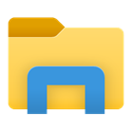

Figure 15: File Explorer Icon

The main way to launch the File explorer is through the taskbar, or by pressing Windows key and E Together or by pressing the Windows key and X together to open the Power User Tasks Menu, after that, select File Explorer the icon or by selecting it in the start menu, there is also different types of ways to launch the file explorer, it can be opened by selecting any folder, selecting the “This PC” or “downloads” folder can also open the file explorer window or through the search function.



Figure 16: File explorer in Task Bar

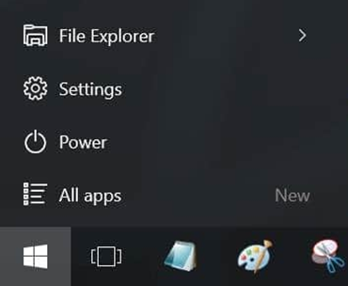

Figure 17: File Explorer in Start menu

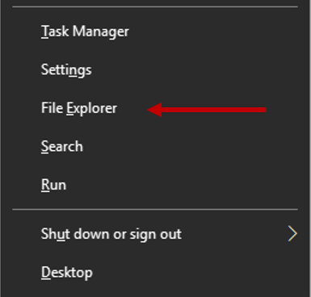

Figure 18: File Explorer in Power User Tasks Menu

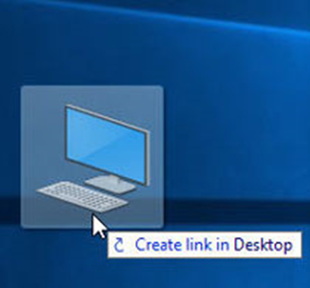

Figure 19: This PC Icon

File Explorer has many functions implemented within it, such as a quick access side tab to conveniently access folders that have been accessed recently or multiple times, as well as folders that have been pinned by the user.

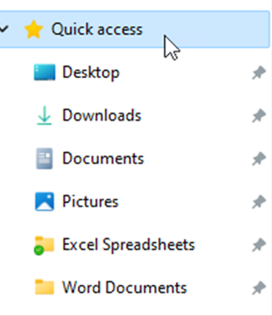

Figure 20: Quick Access in File Explorer

In Windows 10, the File Explorer has a new ribbon menu bar, similar to the one found in recent Microsoft Office releases. And consists of Four tabs: File, Home, Share, and View.

The File tab displays a menu with many options, including:

* Opening a new window in File Explorer.
* Accessing the command window for more experienced users.
* modifying or changing settings that affect File Explorer's behaviour.

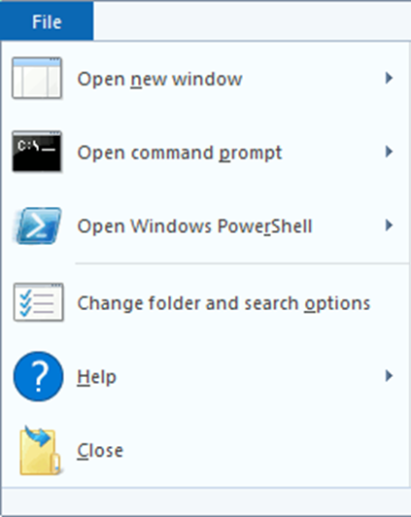

Figure 21: File Tab

Under the Home tab, the ribbon includes buttons and functions for the most frequently used tasks, Such as:

* Transferring files and folders from one spot to another.
* Deleting a file or folder.
* Renaming a file or folder.
* Creating a new folder or item.
* Modifying the properties of a file or folder.

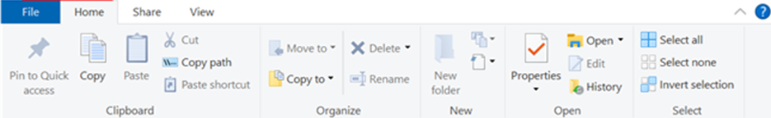

Figure 22: The Home ribbon

Under the Share ribbon, the tab offers various choices for sharing files and folders, Such as:

* Compressing files into a .ZIP file to take up less storage space.
* Emailing a file or sending it via messages.
* Printing Documents or faxing them.

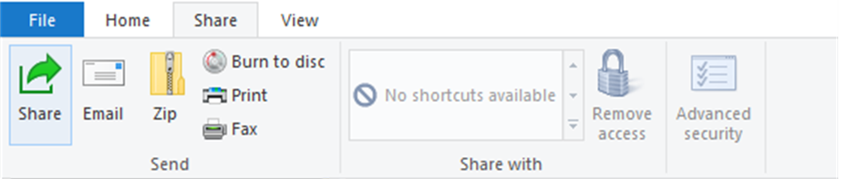

Figure 23: The Share ribbon

The View ribbon lets you customise how Windows displays folders and documents. Some of the improvements are as follows:

* Adding additional tabs to offer a visual or data of your files.
* Changing the file and folder layout from icons to lists, among other things.
* Organising and categorizing the items in your folder
* Hiding specified files or directories.

(*What is File Explorer*, 2021)

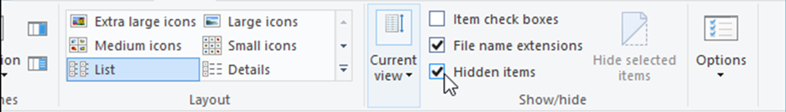

Figure 24: The View ribbon

## 5.2 Security Services in Window 10

Windows 10 provides advanced security services to protect the user’s information and privacy. For example, Windows Hello, Microsoft Defender and automatic updates.

### 5.2.1 Windows Hello

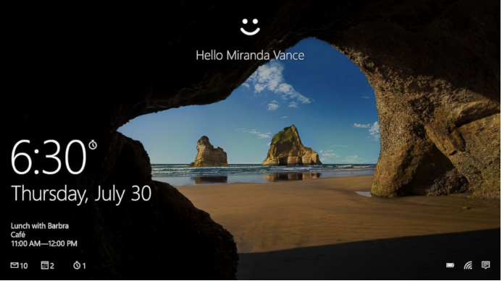

Figure 25 Window Hello (Newcomb, 2015)

Window Hello is a feature provided in Windows 10 operating system for security purposes. With Windows Hello, users can instantly access Windows 10 devices such as HP Victus 16 using a PIN, facial recognition software, or fingerprint in a more private and secure way. While setting up fingerprint or face recognition sign-in requires setting up a PIN, users can also sign in using by just using PIN (Newcomb, 2015). Since the PIN is only linked to one device and is stored up for recovery with the Microsoft account, these options can make it simpler and safer to sign into the device.

### 5.2.2 Microsoft Defender

Microsoft defender also serves as one of the function of Windows 10 to protect the devices. It can safeguard the user’s identity and devices and make sure the devices is staying ahead of hackers and scammers. User can review alerts and take recommended action by using Microsoft Defender. The users will receive alerts if their information is compromised or at risk (Microsoft, n.d.). Additionally, this feature is become free for devices with Window 10.

### 5.2.3 Automatic Updates

To keep laptop safer, Windows 10 delivers automatic upgrades by default, unlike earlier versions of the operating system (Rayome, 2021). This can prevent potential security issues because Microsoft does not stop sending security patches against the most recent vulnerabilities. These patches frequently come to the user automatically because of automatic updates. By doing this, the user’s laptop can be protected from the latest and most sophisticated cyberattacks, just like in the prior instance without user’s intervention.

# 6.0 The Conclusion:

The VICTUS 16 is an acceptable device, and its performance is respectable for its cost, but it also has some disadvantages. The most common disadvantage is weight, it is heavy in case it is a gaming laptop, over 5 pounds and this weight makes the user face some issues with carrying. The size of the keyboard is quite large which effectively affects the speed of writing a specific task. Speakers are muffled when the fans' sound gets loud. From our perspective, the company of this device will be improved much better with the next versions of the VICTUS series. And the operating system for this device is Windows 10, it is one of the most recent versions of Microsoft Windows, and one of the main features of the specific OS is that security. Microsoft makes every effort to keep Windows 10 as secure as possible. Since then, authentication methods have developed significantly. It's difficult for outsiders to figure out a password. Even other forms of authentication, including fingerprint scanning and facial recognition, have improved. Security features similar to encryption are also present in Windows 10. And it seems that the developers will try to solve the common drawbacks with all company devices in the coming years.

**(Total words count: 5544 words)**

# 7.0 References

Warren, T. (2015, July 29). *The story of Windows 10 from inside Microsoft*. The Verge. <https://www.theverge.com/2015/7/29/9060891/microsoft-windows-10-myerson-belfiore-aul-spencer-interview>

Asati, A. (2021, July 13). *What is Windows 10?* EDUCBA. <https://www.educba.com/what-is-windows-10/>

Goldman, D. (2015, July 29). *The man who designed Windows 10*. CNNMoney. <https://money.cnn.com/2015/07/29/technology/terry-myerson-windows-microsoft/index.html>

Todorov, G. (2022, November 7). 45 Impressive HP Stats and Facts: Market Share, Usage and Revenue. ThriveMyWay. <https://thrivemyway.com/hp-stats/>

*Hewlett Packard Enterprise: Number of Employees 2013-2022 | HPE.* (n.d.). MacroTrends. <https://www.macrotrends.net/stocks/charts/HPE/hewlett-packard-enterprise/number-of-employees>

Hall, M. (2022, October 22). *Hewlett-Packard Company | History & Facts*. Encyclopedia Britannica. <https://www.britannica.com/topic/Hewlett-Packard-Company>

*Microsoft Statistics - Microsoft Facts, Stats, Trends & Data (2022) | WallStreetZen*. (2022, November 26). <https://www.wallstreetzen.com/stocks/us/nasdaq/msft/statistics>

Alsop, T. (2022, February 2022). HP Inc. - statistics & facts. Statista. <https://www.statista.com/topics/1122/hewlett-packard/>

*Who is Satya Nadella? Everything You Need to Know*. (n.d.). <https://www.thefamouspeople.com/profiles/satya-nadella-6237.php>

Hollar, S. (2015, July 10). *Satya Nadella | Biography & Facts*. Encyclopedia Britannica. <https://www.britannica.com/biography/Satya-Nadella>

*Terry Myerson Biography | HowOld.co*. (n.d.). <https://www.howold.co/person/terry-myerson/biography>

Warren, T. (2016, June 1). *Microsoft’s Gabe Aul steps aside as the face of Windows 10 testing*. The Verge. <https://www.theverge.com/2016/6/1/11829724/microsoft-windows-10-gabe-aul-steps-aside-windows-insider-role>

Microsoft. (2022, October 18). *Satya Nadella*. Stories. <https://news.microsoft.com/exec/satya-nadella/>

Patrizio, A., & Bigelow, S. J. (2017). *Microsoft*. SearchWindowsServer; TechTarget. <https://www.techtarget.com/searchwindowsserver/definition/Microsoft>

*Microsoft Windows - Introduction, Versions, History & Development*. (2020, August 17). BYJUS. <https://byjus.com/govt-exams/microsoft-windows/>

‌

*What is Windows? | Digital Unite*. (2021). Digitalunite.com. <https://digitalunite.com/computer-basics/windows-10/what-windows>

‌

Lores, E. (n.d.). *Executive Biography*. <https://press.hp.com/content/dam/hpi/press/press-kits/2020/hp-response-covid-19/Enrique%20Lores%20CEO%20bio%20.pdf>

Feldman, A. (2019, October 4). HP’s New CEO Enrique Lores Will Steer A Smaller Printer Company. *Forbes*. <https://www.forbes.com/sites/amyfeldman/2019/10/04/spotlight-on-hp-incoming-ceo-enrique-lores-as-the-printer-giant-announces-a-restructuring-and-plans-to-cut-up-to-9000-jobs/?sh=6cb0433478c8>

Jin. (2014, January 2). *William Redington Hewlett Founder of HP -*. Researchpedia.info. <https://researchpedia.info/william-redington-hewlett-founder-of-hp/>

‌

Jin. (2014, January 2). *David Packard Founder of HP -*. Researchpedia.info. <https://researchpedia.info/david-packard-founder-of-hp/>

Hachman,M. (2021, December 14). *HP Victus 16 (16-d0097nr)*. PCWorld. <https://www.pcworld.com/article/551295/hp-victus-16-review-this-budget-16-inch-gaming-laptop-delivers-solid-value.html>

Fillari, A. (2022, May 12). *HP Victus 16 Review: An Affordable Option for Peak Gaming Performance*. CNET. https://www.cnet.com/tech/computing/hp-victus-16-review-an-affordable-option-for-peak-gaming-performance/

*HP Victus 16 review*. (2022, January 14). Tom’s Guide. <https://www.tomsguide.com/reviews/hp-victus-16-review>

DK ID. (2021, September 23). Laptop Gaming Versi Baru, Lebih Murah, Makin KENCENG! | HP Victus 16 Review. YouTube. https://www.youtube.com/watch?v=48ScEYR5AR0

Jarrod’sTech. (2021, September 24). HP Victus 16 Review - Best Budget Gaming Laptop? YouTube. <https://www.youtube.com/watch?v=W18HaYdl3VM>

Martin, O., Lim, R. & Peroramas, J. (2022, May 17). RTINGS.com. <https://www.rtings.com/laptop/reviews/hp/victus-16-2021>

Victus by HP Laptop 16 Price in Malaysia & Specs - RM3599. (n.d.). TechNave. <https://technave.com/gadget/Victus-by-HP-Laptop-16-Price-in-Malaysia-Specs-30024.html>

Terafied. (2022, August 19). *HP Victus 16 (2022) Review - Still A Great & Affordable Gaming Laptop*. YouTube. <https://www.youtube.com/watch?v=YNZSIgmuASs>

Computer Hope. (2022, October 18). *What is the Start Menu?* <https://www.computerhope.com/jargon/s/startmen.htm>

Tillman, M. (2022, December 1). *What is Microsoft Edge? The lowdown on Microsoft’s replacement for Internet Explorer*. Pocket-lint. <https://www.pocket-lint.com/apps/news/microsoft/133746-what-is-microsoft-edge-the-lowdown-on-microsoft-s-windows-10-browser>

*Windows 10’s Virtual Desktops Give You Multiple Workspaces on Your PC*. (2021, September 8). Lifewire. <https://www.lifewire.com/use-multiple-desktops-in-windows-10-3988671>

*Windows 10 Tablet Mode: What It Is and How to Use It*. (2021, January 21). Lifewire. <https://www.lifewire.com/what-is-windows-10-tablet-mode-4584793>

*Windows 10: Windows 10 Features*. (n.d.). GCFGlobal.org. <https://edu.gcfglobal.org/en/windows10/windows-10-features/1/>

Computer Hope. (2021, November 6). *What is File Explorer?* <https://www.computerhope.com/jargon/e/explorer.htm>

Microsoft. (n.d.). *Microsoft Defender for Individuals | Microsoft 365*. <https://www.microsoft.com/en-us/microsoft-365/microsoft-defender-for-individuals>

Newcomb, A. (2015, August 22). *“Windows Hello” Facial Recognition: Whether Twins Can Fool It*. ABC News. <https://abcnews.go.com/Technology/windows-facial-recognition-twins-fool/story?id=33227840>

Rayome, A. D. (2021c, March 25). *5 Windows 10 features that are better than what you had on Windows 7*. CNET. <https://www.cnet.com/tech/services-and-software/5-windows-10-features-that-are-better-than-what-you-had-on-windows-7/>

# 8.0 Appendices

## 8.1 Work Breakdown Structure

|  |  |  |
| --- | --- | --- |
| **Student** | **Allocation of Work** | **Signatures** |
| S1 Abdulrahman Gamil Mohammed Ahmed  (TP071012) | 1. People  * Introduction to Device (HP VICTUS16) * Introduction to People in (HP) * Introduction to Microsoft * The Conclusion  1. Review hardware and software part |  |
| S2 Jeniffer Su Kai Li (TP065517) | 1. People  * Introduction to HP * People in Microsoft involved in the creation OS (Windows10) * Facts and stats about HP company * Facts and stats about Microsoft company  1. Do minutes of meetings 2. Review software part and add on  * Security Services in Windows 10  1. Review hardware and software part 2. Gantt Chart |  |
| S3 Koshekov Timur  (TP066121) | 1. Hardware  * Tables of the most significant hardware components      1. Review people and software part |  |
| S4 Alexander Surya Ongso  (TP071786) | 1. Hardware  * Introduction to the device (showcase everything that comes out the box) * Conclusion of Hardware  1. Review people and software part 2. Frequently Asked Questions 3. Table of Contents 4. Abstract |  |
| S5 Sohan Singh (TP063586) | 1. Software  * Functions and Capabilities in Windows 10  1. Review people and hardware part |  |
| S6 Shaker Khaled Yuor Lual  (TP068264) | 1. Software  * Functions and Capabilities in Windows 10  1. Review people and hardware part |  |



## 8.2 Minutes of Meeting

**Meeting 1**

|  |  |  |
| --- | --- | --- |
| Team | : | T15-K |
| Date | : | 2/11/2022 |
| Time | : | 2.09pm-3:02pm |
| Place | : | Microsoft Teams |
| Attendees | : | 1. Jeniffer Su Kai Li 2. Alexander Surya Ongso 3. Timur Koshekov 4. Abdulrahman Gamil Mohammed Ahmed 5. Shaker Khaled Your Lual |
| Member not in attendance | : | 1. Sohan Singh |
| Reports | : | We decided the computing device is the hp Victus 16. The operating system we selected is Windows 10. We did the work breakdown structure in separating the job of each member in the people, hardware, and software part. |
| Agenda need to discuss in next meeting | : | 1. Specify the separation parts of each member |

|  |  |  |
| --- | --- | --- |
| Jeniffer Su Kai Li |  | 2/11/2022 |
| Secretary |  | Date of Approval |

**Meeting 2**

|  |  |  |
| --- | --- | --- |
| Team | : | T15-K |
| Date | : | 12/11/2022 |
| Time | : | 1.30pm-2:05pm |
| Place | : | Microsoft Teams |
| Attendees | : | 1. Jeniffer Su Kai Li 2. Alexander Surya Ongso 3. Timur Koshekov 4. Abdulrahman Gamil Mohammed Ahmed 5. Shaker Khaled Your Lual 6. Sohan Singh |
| Member not in attendance | : | None |
| Reports | : | * The specific separation part for each member had been done (Can refer to work breakdown structure). * All members need to complete their personal part in this one-week holiday (14 November 2022 - 21 November 2022) |
| Agenda need to discuss in next meeting | : | 1. Combine all member's work 2. Complete Introduction and Conclusion |

|  |  |  |
| --- | --- | --- |
| Jeniffer Su Kai Li |  | 12/11/2022 |
| Secretary |  | Date of Approval |

**Meeting 3**

|  |  |  |
| --- | --- | --- |
| Team | : | T15-K |
| Date | : | 2/12/2022 |
| Time | : | 5.15pm-6.20pm |
| Place | : | Microsoft Teams |
| Attendees | : | 1. Jeniffer Su Kai Li 2. Alexander Surya Ongso 3. Koshekov Timur 4. Abdulrahman Gamil Mohammed Ahmed 5. Sohan Singh |
| Member not in attendance | : | 1. Shaker Khaled Your Lual |
| Reports | : | * Review and discuss on the progress of the people, software and hardware part. * Done cover page * Separate works should be done by 9/12/2022(Friday) |
| Agenda need to discuss in next meeting | : | 1. Review and discuss the part of each member do 2. Do Table of Content 3. Do references |

|  |  |  |
| --- | --- | --- |
| Jeniffer Su Kai Li |  | 3/12/2022 |
| Secretary |  | Date of Approval |

Meeting 4

|  |  |  |
| --- | --- | --- |
| Team | : | T15-K |
| Date | : | 17/12/2022 |
| Time | : | 7pm-7:30pm |
| Place | : | Microsoft Teams |
| Attendees | : | 1. Jeniffer Su Kai Li 2. Alexander Surya Ongso 3. Koshekov Timur 4. Abdulrahman Gamil Mohammed Ahmed 5. Shaker Khaled Your Lual 6. Sohan Singh |
| Member not in attendance | : | None |
| Reports | : | Review all the contents, format, references and do the last checking before submit group assignment. |
| Agenda need to discuss in next meeting | : | None |

|  |  |  |
| --- | --- | --- |
| Jeniffer Su Kai Li |  | 17/12/2022 |
| Secretary |  | Date of Approval |

## 8.3 Frequently Asked Questions

FAQ

**Software**

1. Is there windows 9?

Windows 9 never existed; instead, Microsoft switched to Windows 10. Officials at the company made the decision to go with 10 because they think it represents the final major Windows version and is a "Perfect 10." There will still be Windows 10 updates known as feature updates, but don't anticipate a Windows 11, Windows 12, or anything else. Windows 10 was originally planned to be a tiny Upgrade 2 for Windows 8.1, and it was first unveiled at BUILD 2014 as a small update called "Threshold." Plans altered somewhere along the road, and the operating system developed into the significant update we have today.

1. Do windows 10 need internet to be powered on?

For regular use, Windows 10 doesn't need to be connected to the Internet. You can do whatever you would typically do in Windows 7 or an earlier version when it is offline and it works perfectly.

1. Will upgrading to Windows 10 have an impact on my computer's other drives, partitions, or information within those partitions?

No, the upgrade will only affect the drive from which it is started. Non-system drives can always be disconnected as a safety measure.

1. What is RTM?

Release to Manufacturing, or RTM, is a stage in the development of software. While not directly related to Windows 10, historically it served as a sign for determining when a build was ready for production environments where it could be deployed, used for daily computing, and preloaded on new machines.

1. How to get windows 10 and how much is it?

The Windows 10 update may be purchased straight from Microsoft here for about $139. If your machine uses Windows 7 or Windows 8.1 and fulfils the system requirements, you'll be able to download and install Windows 10 on your existing computer. Most new PCs also come with Windows 10 pre-installed.

**Hardware**

1. can the ram on the hp victus 16 laptop be upgraded?

Through two SODIMM slots that can accommodate up to 64GB of RAM and two M.2 PCIe x4 disc slots for SSD expansion, the laptop enables both RAM and storage upgradeability.

1. What is the display quality?

Two 16.1-inch Full HD IPS screens, one of which has a refresh rate of 144Hz, are included with the laptop.

1. Does the battery on the HP victus 16 laptop last long?

With hardware of this caliber and a battery unit of 70Wh. With 10 and a half hours of Web browsing and 7 hours and 40 minutes of video playback, the laptop held up well.

1. Is the HP brand laptop good?

HP is among the top five manufacturers in terms of customer support options. Additionally, you can get yourself some serious protection for your new laptop with options for a comprehensive warranty that lasts up to three years.

1. What is the best hp gaming laptop?

HP has a few gaming-specific brands in its portfolio, with the Omen family likely being the most well-known. However, the company's lineup also includes other names you can use for gaming, like the just-released Victus line.

## 8.4 Gantt Chart

